Network of Networks: End-of-Year Report

Zoe Gastelum

International Safeguards and Engagements

Sandia National Laboratories

# Introduction

In fiscal year (FY) 2016, Zoe Gastelum, Senior Member of the Technical Staff at Sandia National Laboratories (SNL) joined the on-going Network of Networks (A.K.A. NetSci) project with existing collaborators James Hart Kornell (Special Technologies Laboratory) and Bethany Goldblum (University of California, Berkeley). This report documents the technical contributions to the project by SNL for FY2016.

# Traditional and New Media Report

In March 2016, SNL completed an overview of open source English-language data that can be used to support nuclear fuel cycle analysis, including both traditional open sources and “new media” sources. It also included some grey literature, i.e., information that is not completely open source such as data available to IAEA Safeguards staff members via internal databases. The document was intended to offer a preliminary understanding of some broad categories of information that may be available in open sources, and provide guidance on that data might be used to support fuel cycle analysis, including types of indicators potentially available in each source.

Traditional open sources referred to in the overview included both hard-copy and electronic sources of information that are (usually) publically available, including news sources, scientific and technical literature, information on technical cooperation and education exchanges (referred to an internal-use IAEA database), trade and customs data, IAEA databases on declared nuclear capabilities, patent databases, nuclear trafficking data, individual government, university, and industry sites, and satellite and other imagery data.

Social media refers to public content that is created by individuals for broader consumption, sharing, or viewing. Traditional social media is often limited in scope to platforms in which users define follow/friend/connection relationships with others to form a directed social network. New media is the high-volume, highly-interconnected, publicly available electronic (i.e. on the Internet) data produced by users who generate data for open use. While this definition was at first limited to traditional social media sites in which users define mutual relationships with one another through shared interests or real-life connections, new media goes beyond the “known” social network to interactions facilitated via the internet of people, websites, and content. In new media, directed social relationship definitions are not required, and can include platforms such as social work sites, public blogs, comments on news sites, and so on. Social and new media sources included in the overview were blogs, microblogs, social networking sites, photo, video, and audio sharing sites, wikis, social news, social games, geosocial apps, social elicitation (i.e. “crowdsourcing”), and review/recommendation sites. Social bookmarking, version control, and dark web sites were determined to be outside the scope of this overview.

An unclassified copy of the overview of traditional and new media can be made available upon request. Preliminary discussion of potential indicators is included only in a classified version of the overview.

# Invited Book Chapter – Societal Verification

In April, I submitted (with some support from NetSci funding) an invited book chapter: Gastelum, Zoe N. “Societal Verification for Nuclear Nonproliferation and Arms Control,” Nuclear Non-proliferation and Arms Control Verification: Innovating Systems Concepts. Ed. Mona Dreicer, Irmgard Niemeyer, and Gotthard Stein. (Forthcoming.). The chapter drew heavily on the new media sources described in the section above, and explored societal verification through two mechanisms of collecting and analyzing societally-produced data, mobilization and observation. It described current applications and research in each area before providing an overview of challenges and considerations that must be addressed in order to bring societally-produced data into an official verification regime. The chapter concluded by emphasizing that the role of societal verification, if any, in nonproliferation and arms control will supplement, rather than supplant, traditional verification means.

# S&T Literature Analysis for Uranium Mining and Million

From May through August, I conducted research on how scientific and technical literature could be used to support the network analysis model being developed by UC Berkeley.

I collected 2,733 bibliographic records from the IAEA Nuclear Information Service database using a basic search string for uranium mining for the years 1948 – 1973.[1] From those records, I produced an index in the SNL-developed software Citrus, for easier text analysis. From there, I was able to determine the total number of times an author from one country published with someone from another country.

Using this data, I ran multiple correlation experiments to determine if the number of a country’s total publications related to uranium mining, their number of co-publications on uranium mining, or several normalized publication and co-publication metrics were related to the country’s level of nuclear fuel cycle development (according to Mathew Furhmann’s nuclear capability database). I found that, for the publications and years that were included in my collection, the results were not significant.

I also created several graph visualizations of the data by year in preparation for a broader graph analysis. However, given the limited co-publication rate during the period of analysis, I determined that such analysis was not appropriate for the available data. Example graphs are shown in Figures 1-4 below.

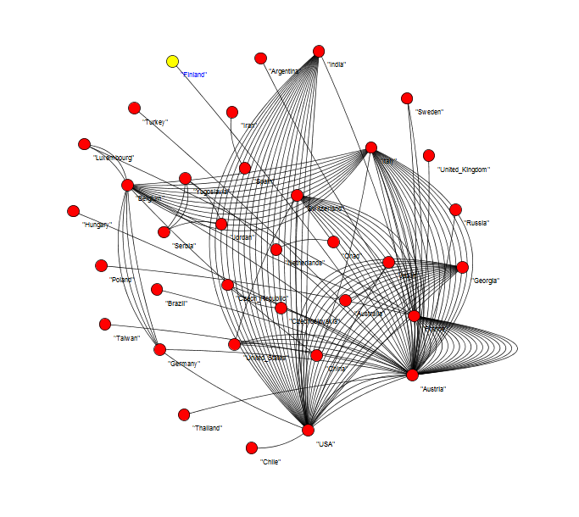

Figure 1All Country-Year Co-publications on Uranium Mining: 1948-1973

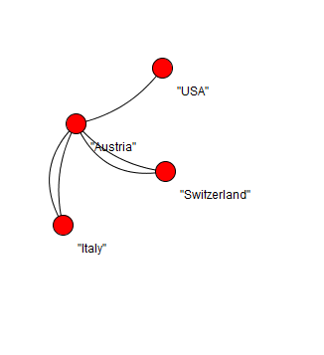

Figure 2 1969 Co-publications by country

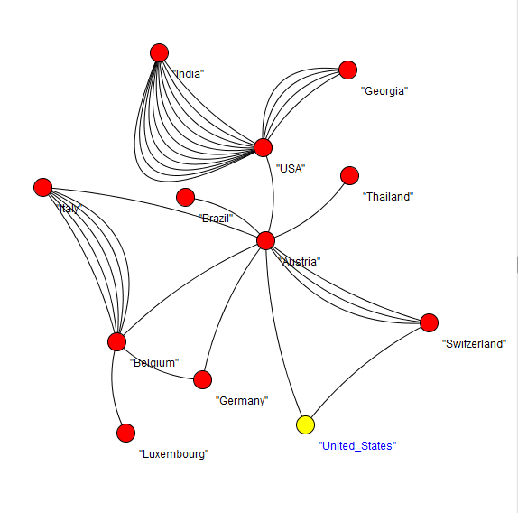

Figure 3 1971 Co-publications by country

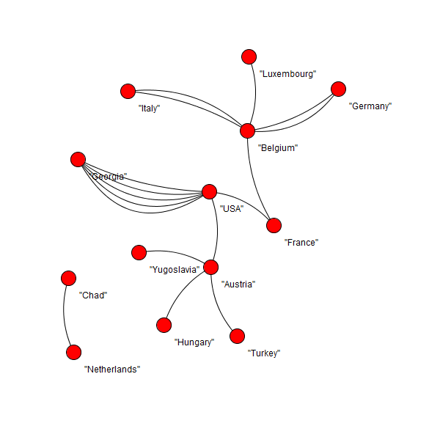

Figure 4 1973 Co-publications by country

# ANS Social Media for Nuclear Nonproliferation Workshop

As part of the Network of Networks project, I will participate in the American Nuclear Society’s Nuclear Nonproliferation Technology & Policy Conference: Bridging the Gaps in Nuclear Nonproliferation, September 25-30, 2016, in Santa Fe, NM. I will host a workshop on Social Media for Nuclear Nonproliferation on Sunday, September 25, covering three aspects of social media relevant for this project: societal observation, societal mobilization, and communication and networking. I will also be chairing a session on Open Source Information Analysis for Verification. The majority of planning and preparation for the workshop were done on my own time, so project funds are being used to support travel, workshop participation, and minimal planning efforts.

1. Historic dates used for two reasons: first, to avoid sensitivity per guidance from the client; and second, because the INIS system developed a bug in which I was no longer able to download more than 50 records at a time, thus rendering significant additional collection from the source infeasible.